Assignment 4 solutions
Name: Lino Joseph
Roll number: be24b028

Answers:
Github link: https://github.com/NightCoderLJ/Bioinformatids_Assignments_be28/tree/19ebb99326a78d281b4ef624eaba9e39a037a0c8/assignment%204

1. a. Write a program to construct a dot plot for the alignment of human and chicken
hemoglobin β chain. Identify the segments, which are same in both sequences.
b. Construct the dot plot manually for the residues 1-20 and verify with the plot
obtained using program
Sequence retrieval:
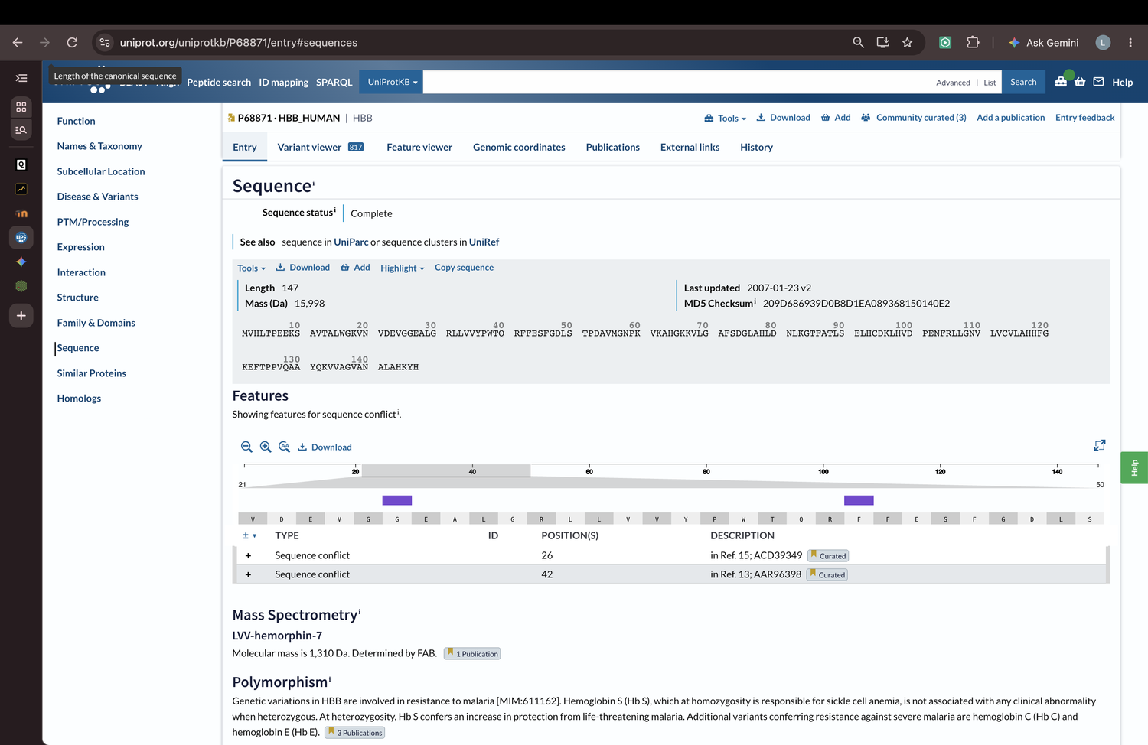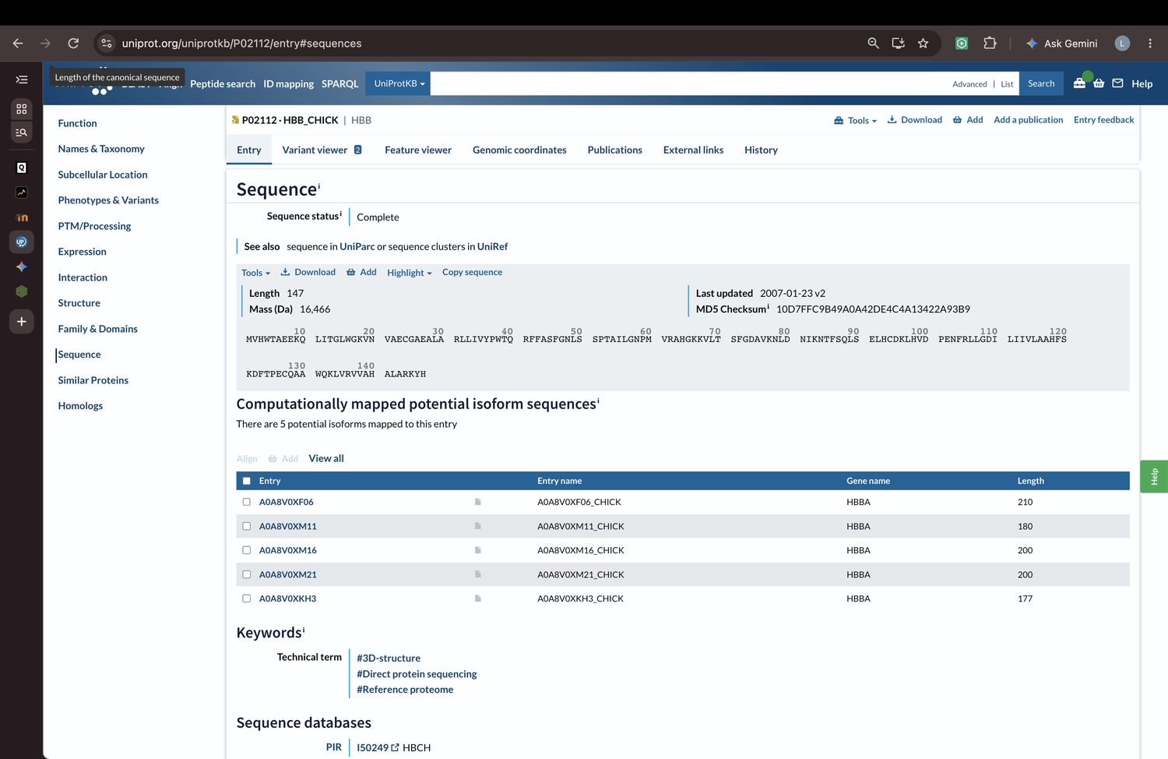
Code and dot plot output:
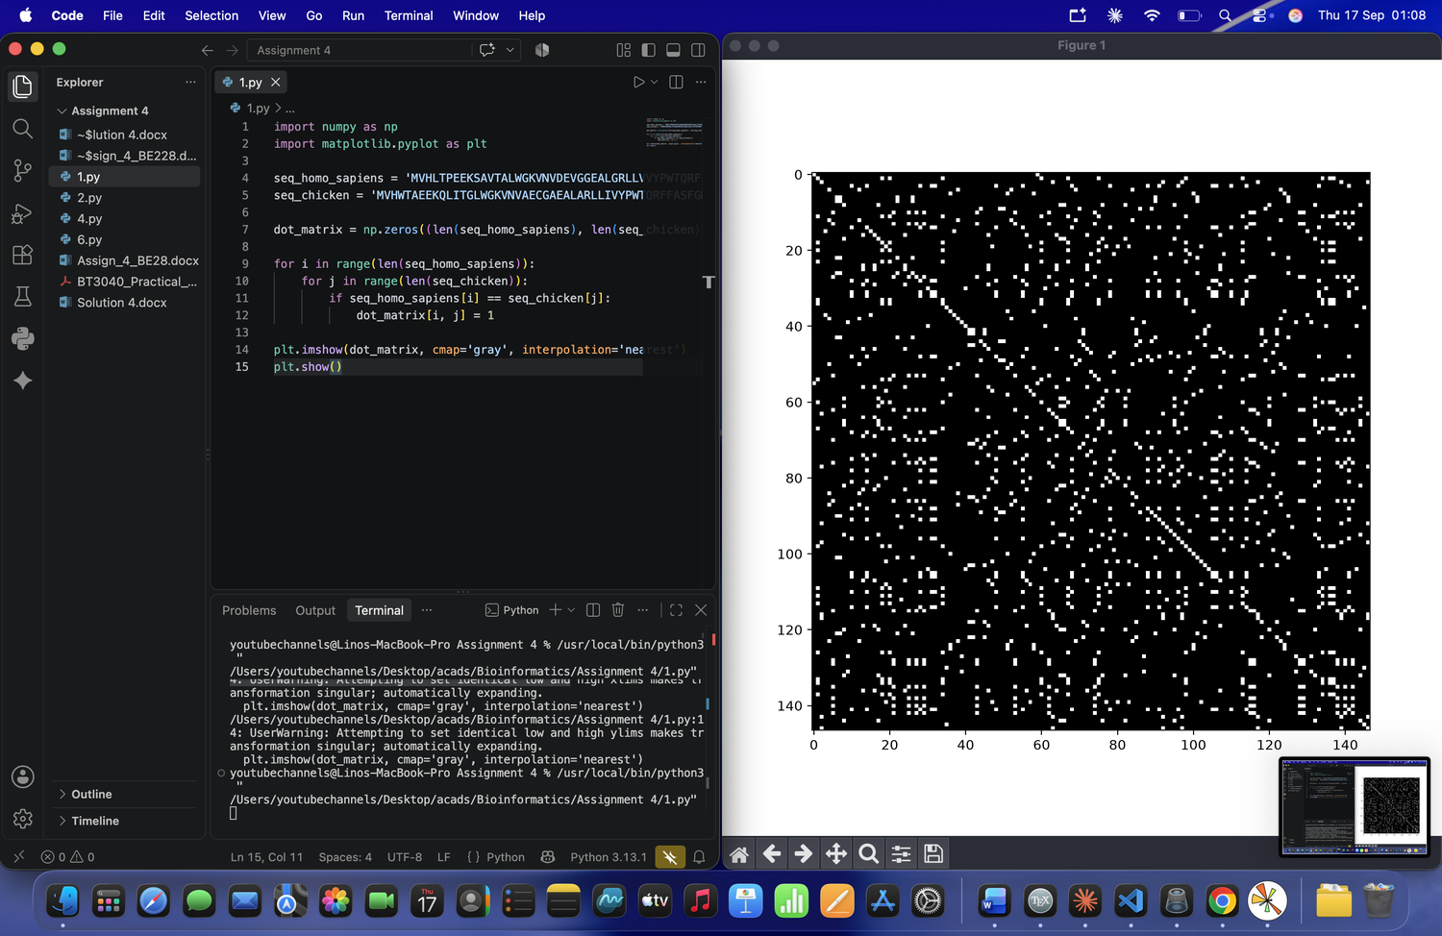
b. Manual dot plot (residues 1–20):
 | M | V | H | L | T | P | E | E | K | S | A | V | T | A | L | W | G | K | V | N
M | ●
V |  | ● |  |  |  |  |  |  |  |  |  | ● |  |  |  |  |  |  | ●
H |  |  | ●
W |  |  |  |  |  |  |  |  |  |  |  |  |  |  |  | ●
T |  |  |  |  | ● |  |  |  |  |  |  |  | ●
A |  |  |  |  |  |  |  |  |  |  | ● |  |  | ●
E |  |  |  |  |  |  | ● | ●
E |  |  |  |  |  |  | ● | ●
K |  |  |  |  |  |  |  |  | ● |  |  |  |  |  |  |  |  | ●
Q
L |  |  |  | ● |  |  |  |  |  |  |  |  |  |  | ●
I
T |  |  |  |  | ● |  |  |  |  |  |  |  | ●
G |  |  |  |  |  |  |  |  |  |  |  |  |  |  |  |  | ●
L |  |  |  | ● |  |  |  |  |  |  |  |  |  |  | ●
W |  |  |  |  |  |  |  |  |  |  |  |  |  |  |  | ●
G |  |  |  |  |  |  |  |  |  |  |  |  |  |  |  |  | ●
K |  |  |  |  |  |  |  |  | ● |  |  |  |  |  |  |  |  | ●
V |  | ● |  |  |  |  |  |  |  |  |  | ● |  |  |  |  |  |  | ●
N |  |  |  |  |  |  |  |  |  |  |  |  |  |  |  |  |  |  |  | ●

2. Calculate the score for the following alignments using code:
AATCTATA
AAG--ATA
Assume that the match score is 1, mismatch score is 0, origination penalty is -2, and
length penalty is -1.
Code and output:
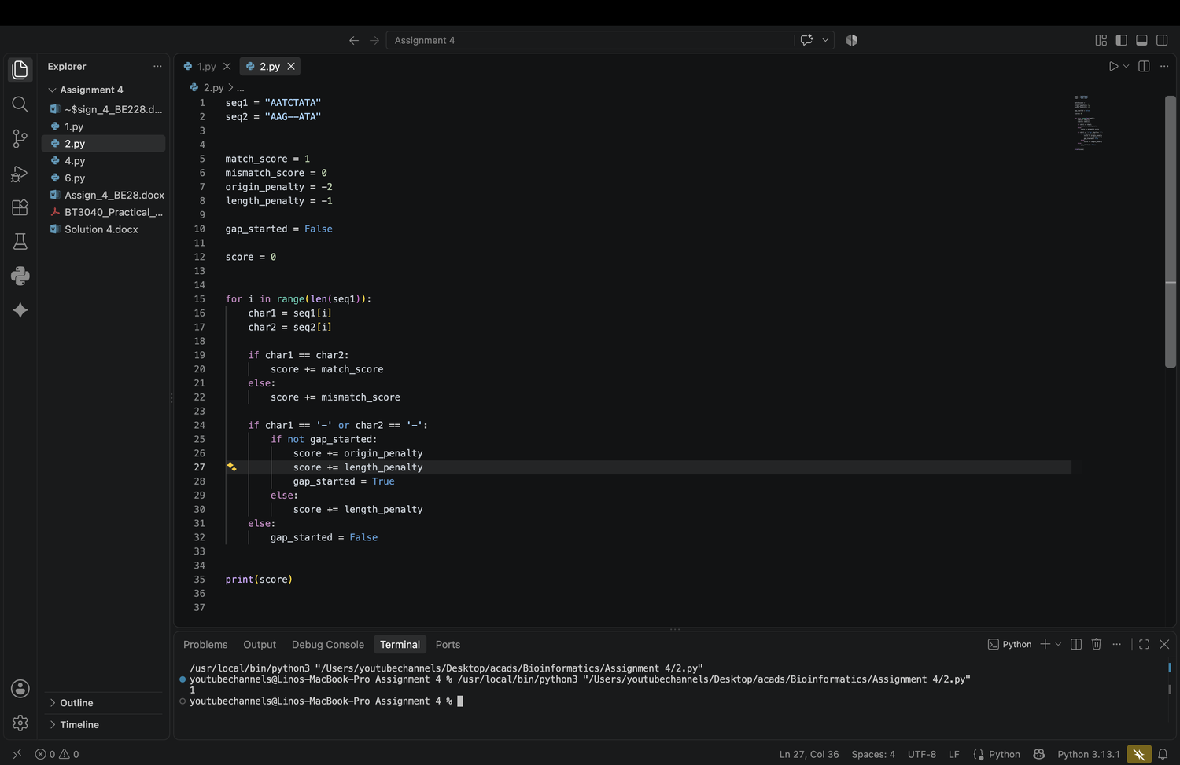
3. Verify the Q2 manually

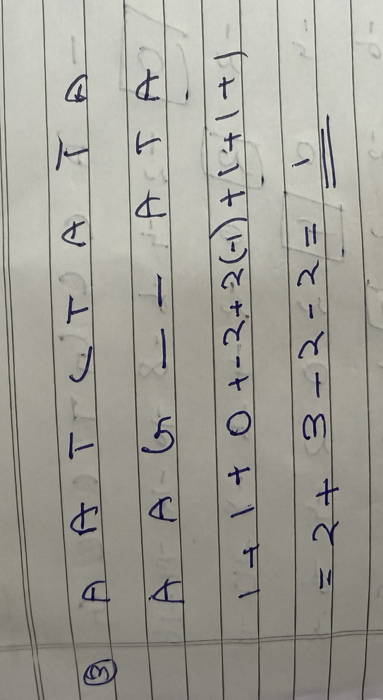
4. Using the Needleman and Wunsch dynamic programming method, construct the
partial alignment score table and align the following two sequences (using code):
ACAGTCGAACG and ACCGTCCG
use the scoring parameters: match score: +2; mismatch score: -1 and gap penalty: -2
Code:
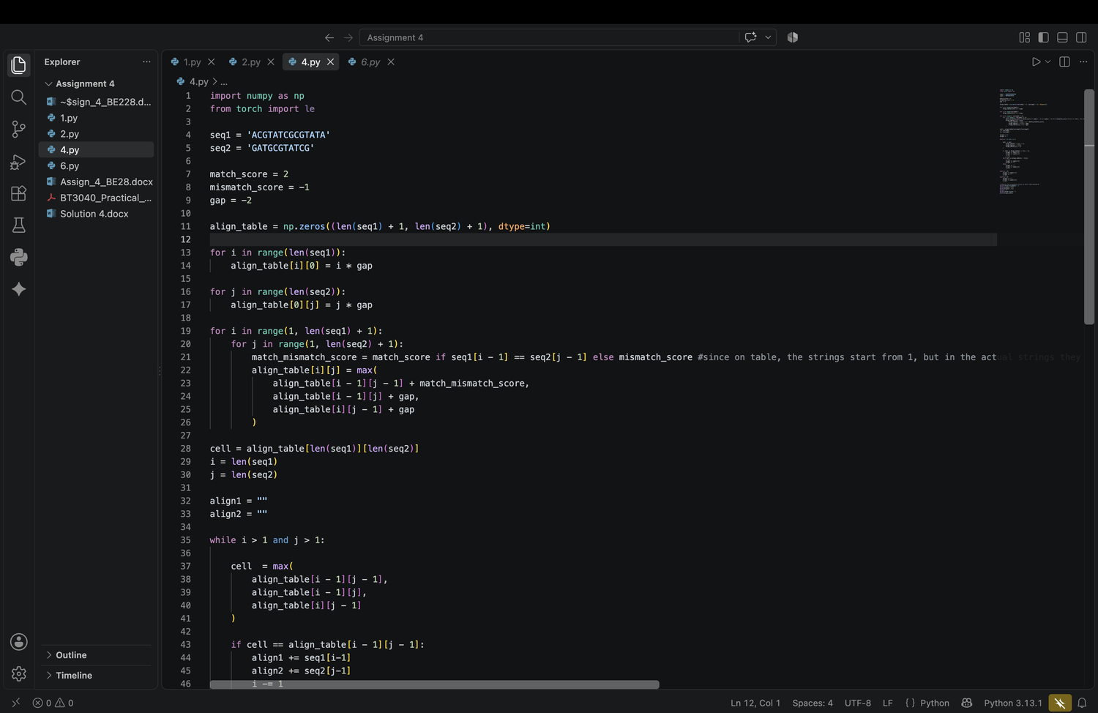
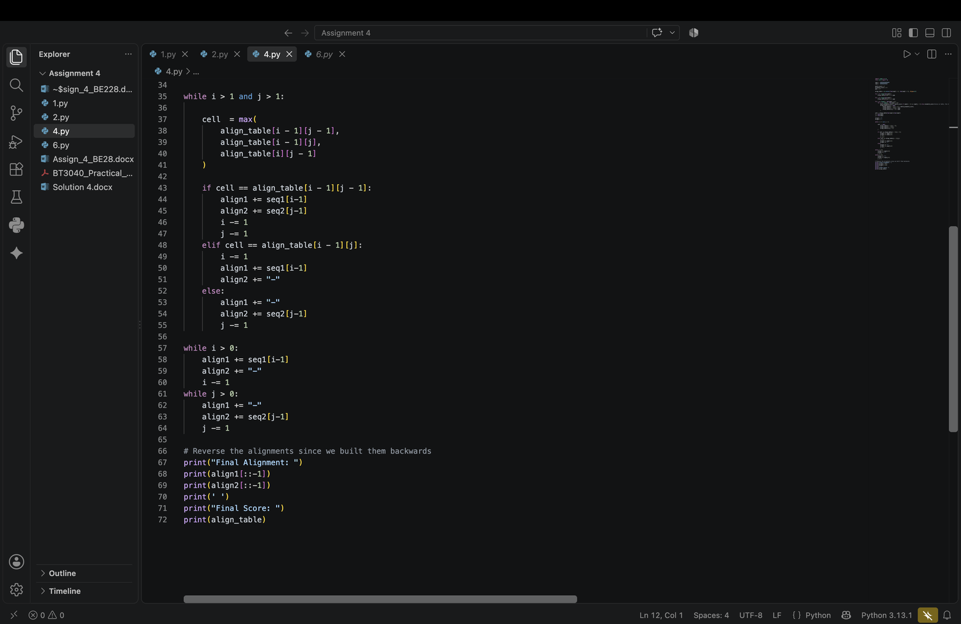
Output:
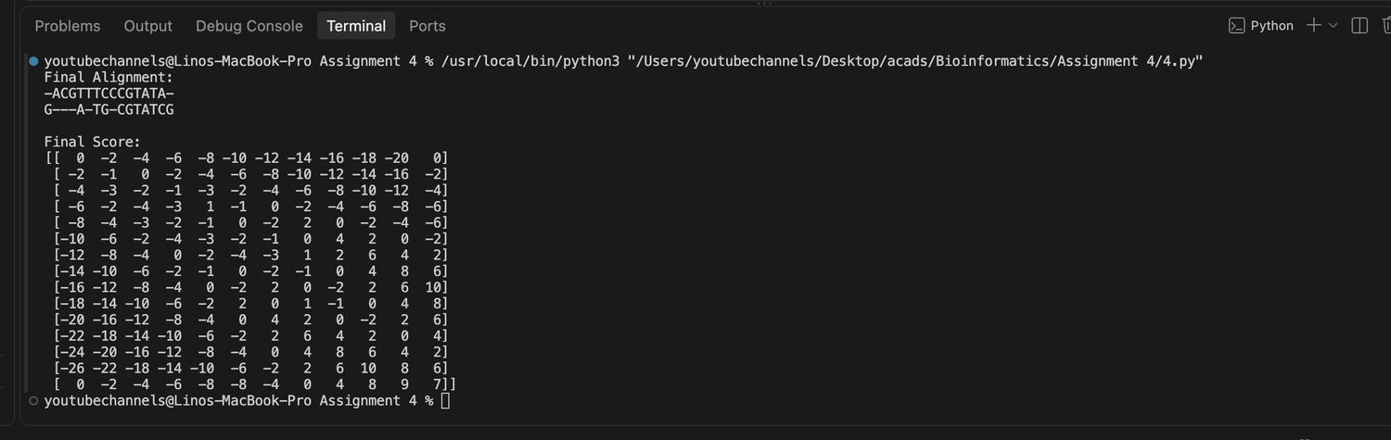

5. Verify Q4 manually
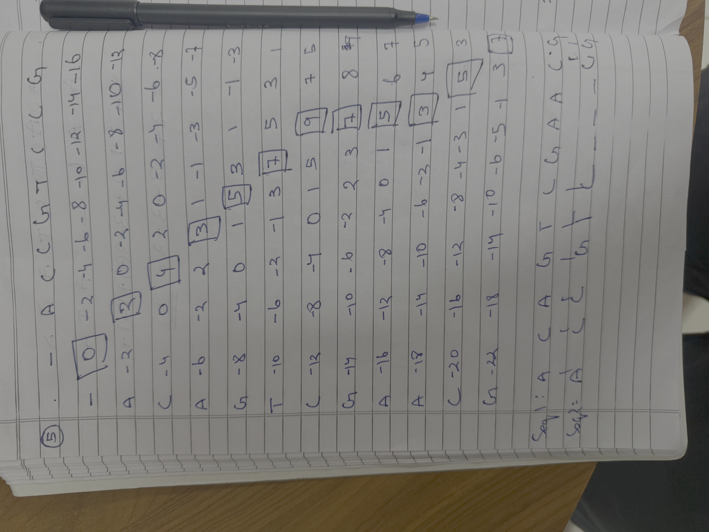
6. Using the Smith-Waterman method, construct the partial alignment scoring table and align
the following two sequences (using code):
ACGTATCGCGTATA and GATGCGTATCG
scoring parameters: match score: +2; mismatch score: -1 and gap penalty: -2
Code:
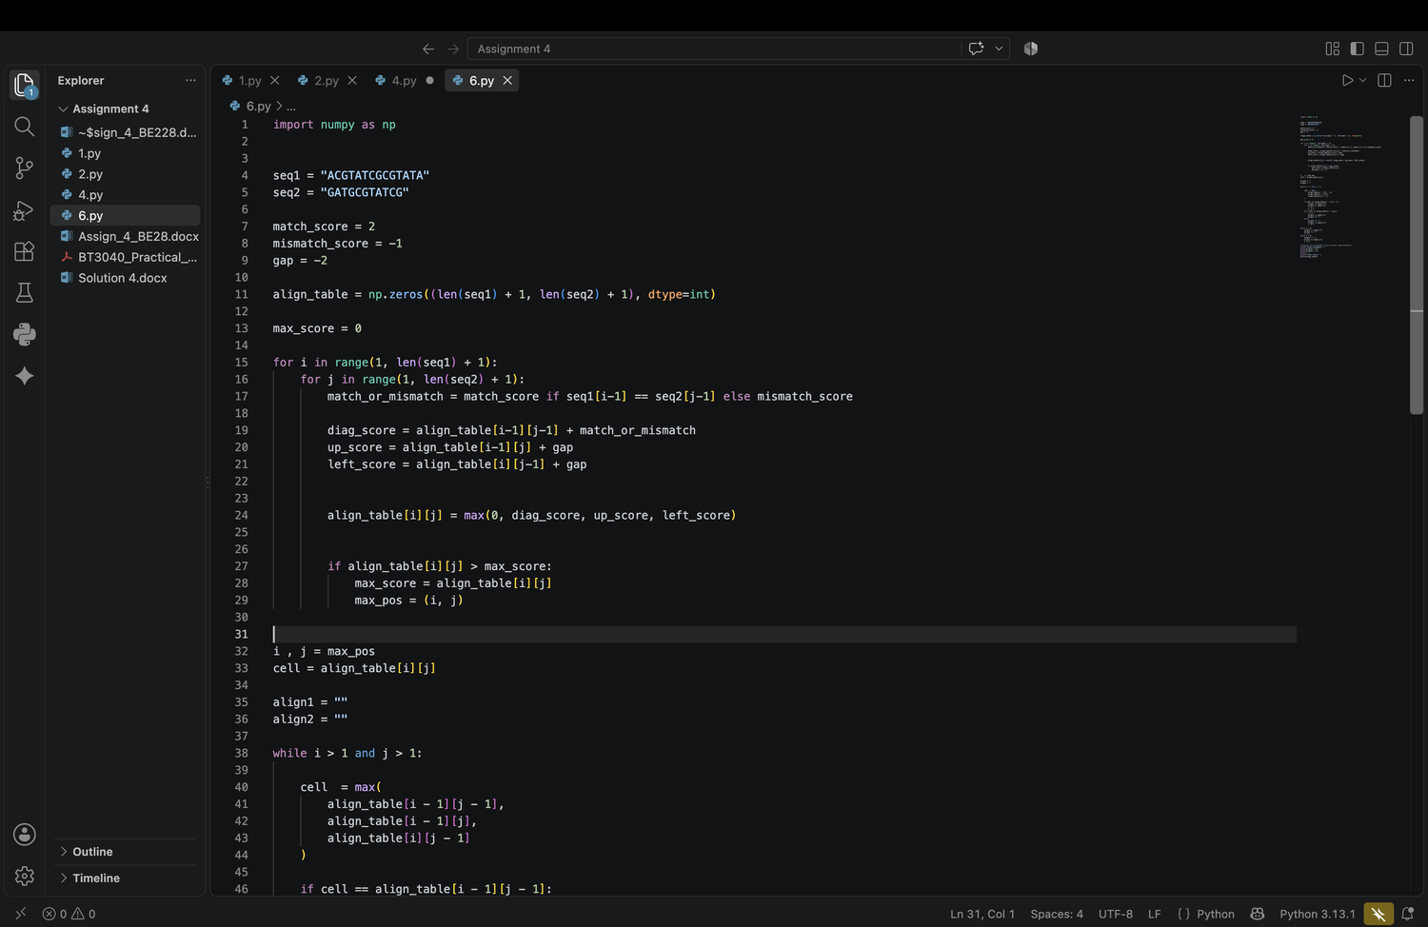
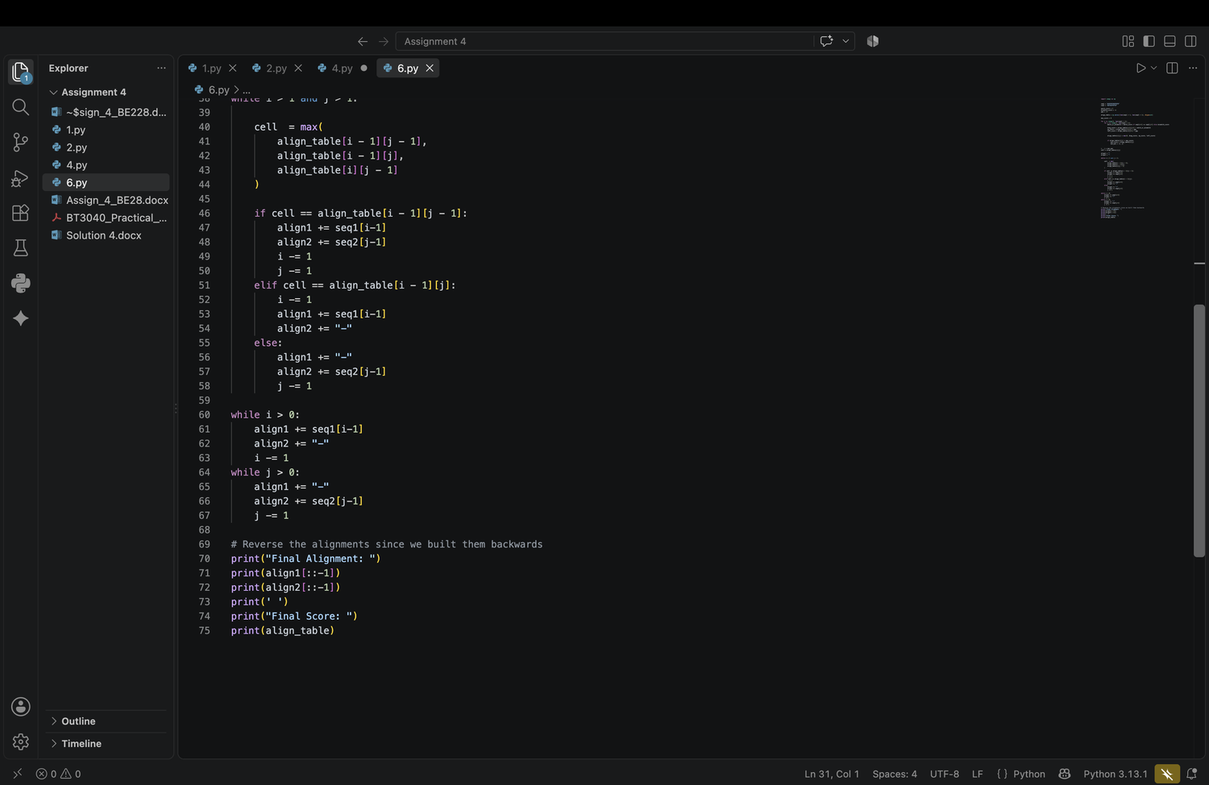
Output:
